Activity-5
Eddu Suchier-192524070

1. Geospatial Data Visualization
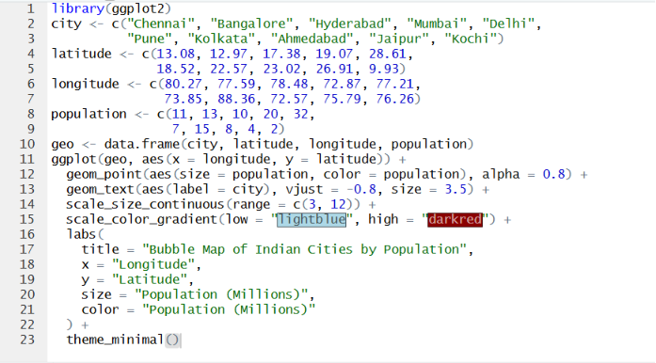
Dataset
City | Latitude | Longitude | Population (Millions)
Chennai | 13.08 | 80.27 | 11
Bangalore | 12.97 | 77.59 | 13
Hyderabad | 17.38 | 78.48 | 10
Mumbai | 19.07 | 72.87 | 20
Delhi | 28.61 | 77.21 | 32
Pune | 18.52 | 73.85 | 7
Kolkata | 22.57 | 88.36 | 15
Ahmedabad | 23.02 | 72.57 | 8
Jaipur | 26.91 | 75.79 | 4
Kochi | 9.93 | 76.26 | 2
Questions

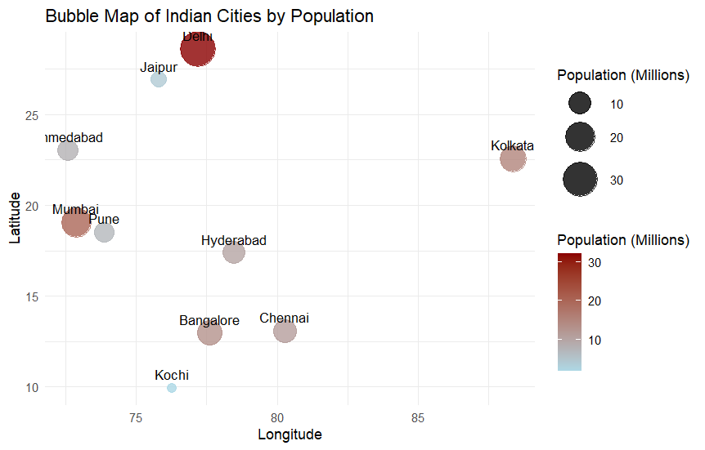

5. Delhi has the highest population (32 million) and appears as the largest and darkest bubble on the map.

2. Network Visualization
Dataset
From | To
A | B
A | C
B | D
C | D
C | E
D | E
E | F
F | G
G | H
H | A
Questions
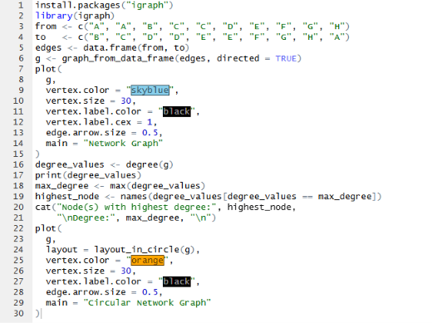
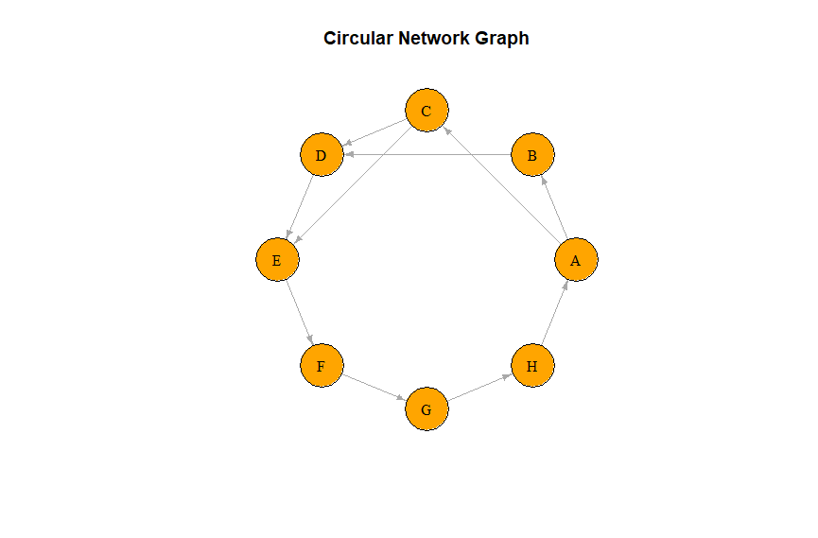

3. A-3, B-2, C-3, D-3, E-3, F-2, G-2, H-2.
4. The nodes with the highest degree are A, C, D, and E, each having 3 connections.

3. Temporal Data Representation
Dataset
Month | Sales (₹ Lakhs)
Jan | 120
Feb | 135
Mar | 150
Apr | 170
May | 190
Jun | 220
Jul | 210
Aug | 230
Sep | 250
Oct | 270
Nov | 290
Dec | 320
Questions
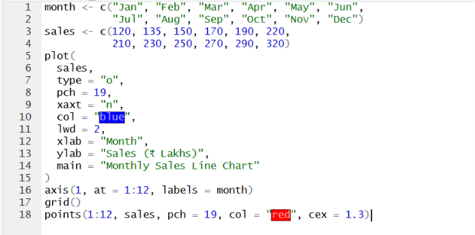
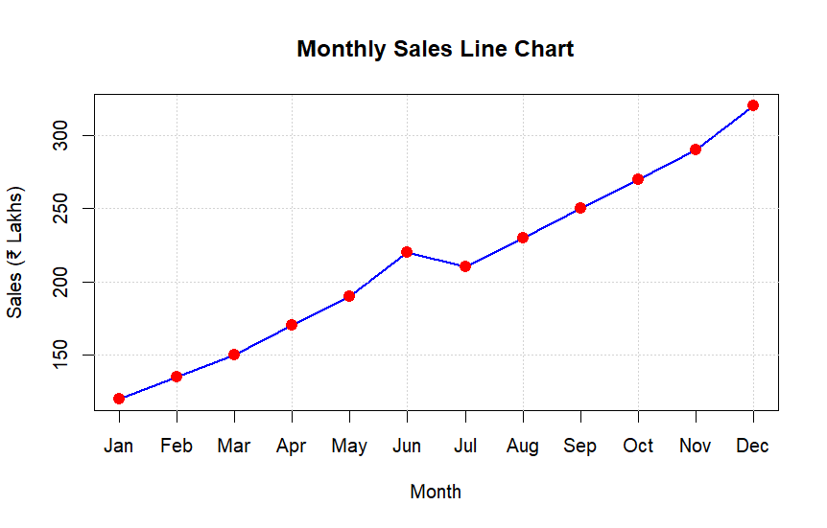

5. December has the maximum sales, with ₹320 lakhs, and appears as the highest point on the line chart.

4. Multivariate Data Visualization
Dataset
Student | Marks | Attendance (%) | Study Hours | Projects
A | 60 | 75 | 2 | 1
B | 68 | 80 | 3 | 2
C | 74 | 84 | 4 | 2
D | 79 | 88 | 5 | 3
E | 82 | 90 | 5 | 3
F | 85 | 92 | 6 | 4
G | 88 | 94 | 6 | 4
H | 91 | 95 | 7 | 5
I | 94 | 97 | 8 | 5
J | 97 | 99 | 9 | 6
Questions
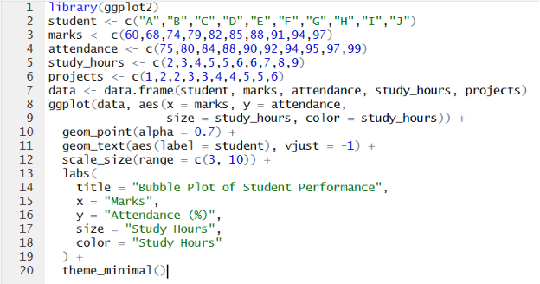
1

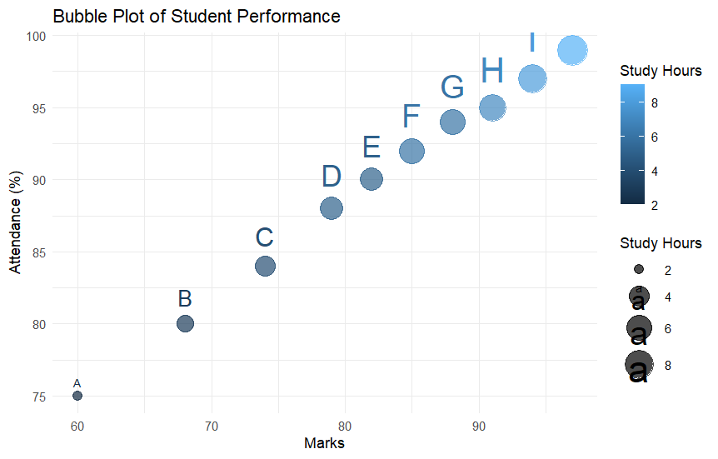

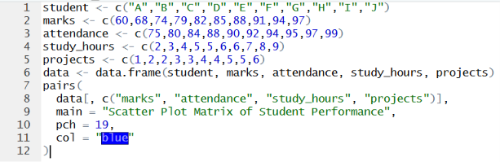
2.

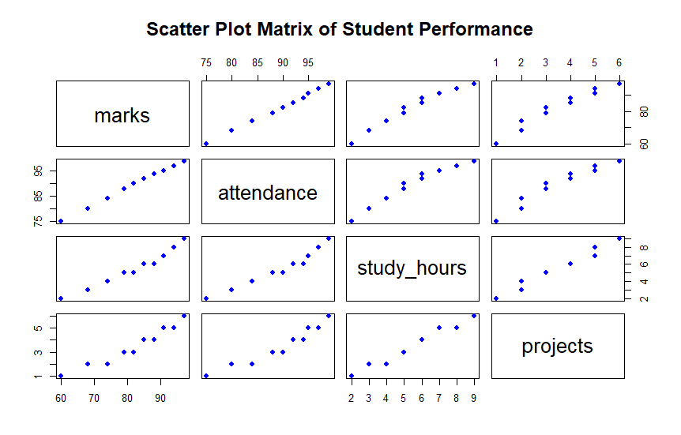

3. 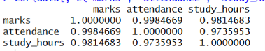
4. Student J has the highest marks (97) and also has the largest bubble, as the bubble size represents Study Hours (9 hours).
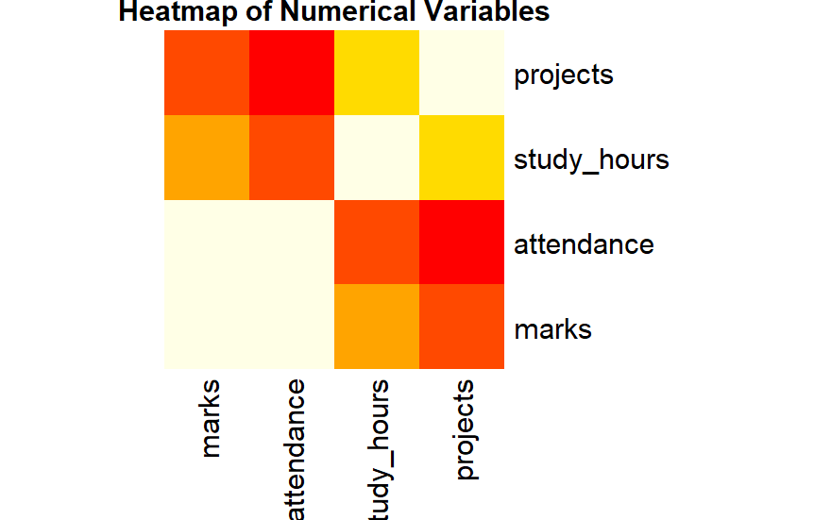
5.
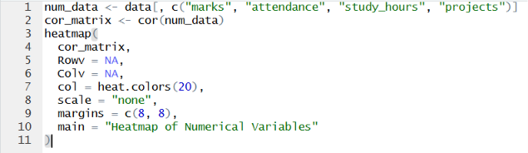

5. Integrated Data Visualization Exercise
Dataset
Year | Sales | Profit | Customers | Branches
2016 | 150 | 20 | 1200 | 5
2017 | 170 | 25 | 1500 | 6
2018 | 200 | 32 | 1800 | 7
2019 | 240 | 40 | 2200 | 8
2020 | 260 | 42 | 2400 | 8
2021 | 300 | 55 | 2800 | 10
2022 | 340 | 65 | 3300 | 11
2023 | 390 | 72 | 3800 | 12
2024 | 430 | 82 | 4200 | 13
2025 | 480 | 95 | 4700 | 15
Questions
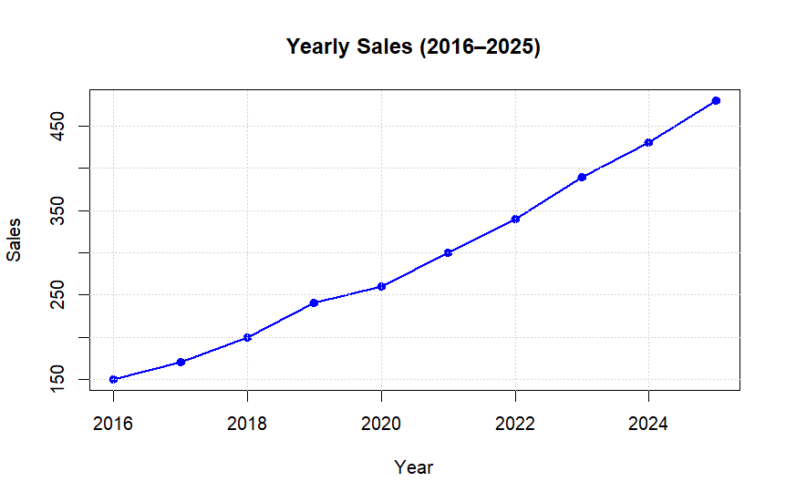
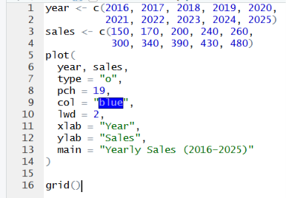
1.

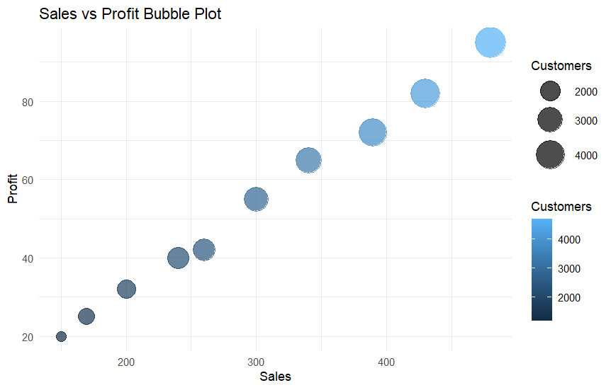
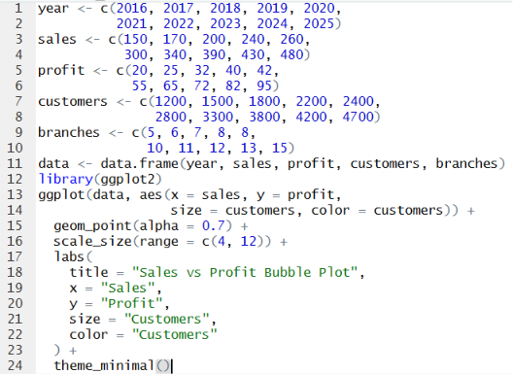
2.

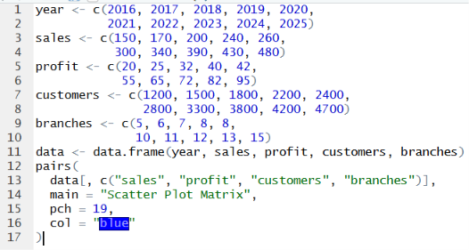
4.

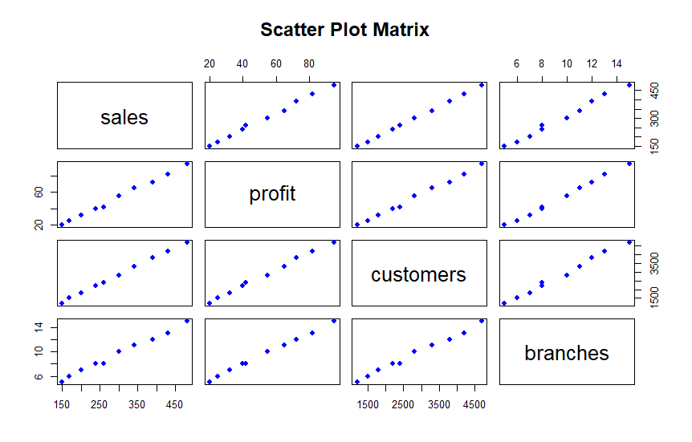

5. As the number of branches increases, both sales and profits increase, indicating a strong positive relationship.

